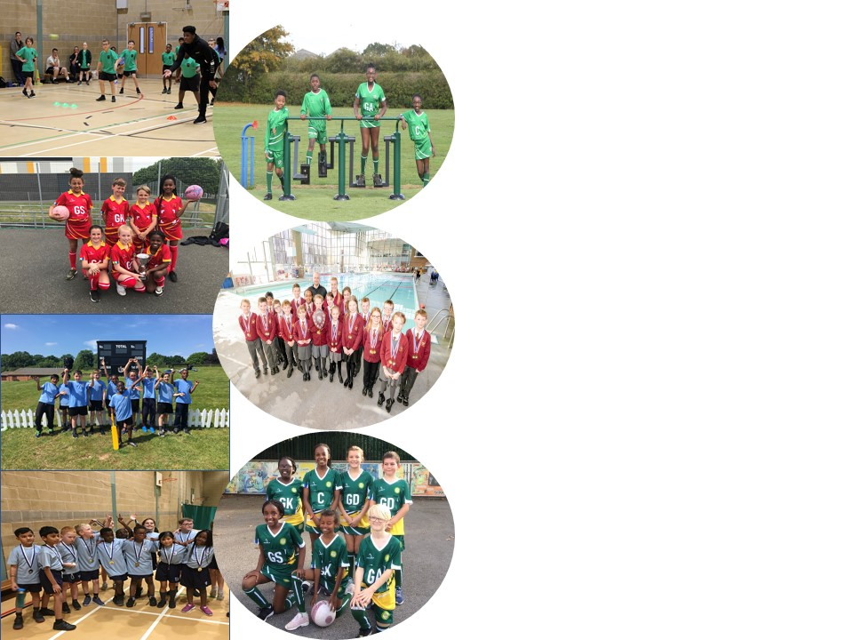
St Gregory’s Catholic Primary School
Sports Funding Impact and Analysis Statement
Following pages are tables showing impact of Government Sports Funding for 2019 – 2020

St Gregory’s Catholic Primary School
Harry Rose Road, Coventry, CV2 5AT
t: 02476 445900 e: admin@st-gregorys.coventry.sch.uk w: stgregorys-coventry.org.uk

Background:

The Government has provided funding until 2020 to provide new, substantial primary school sport funding. This funding is being jointly provided by the Department for Education, Health and Culture, Media and Sport, and will see money going directly to primary school Headteachers to spend on improving the quality of sport and PE for all their children.

The sport funding can only be spent on sport and PE provision in schools. OFSTED will play a significant role in ensuring that schools target this funding in areas which will lead to clear outcomes in raising standards and opportunities in PE and school sport for all children throughout the Primary Phase. All schools receive a lump sum of £16,000 plus an additional £10 per pupil. We are proud of the PE curriculum and sporting opportunities that we have on offer at St Gregory’s Catholic Primary School. We believe that the purpose of Physical Education is to inspire and motivate all children to be active in their lives, enabling them to become physically confident. The importance of living a healthy lifestyle and taking regular exercise needs to be encouraged, alongside the teaching of key fundamental skills. We believe that children should have opportunities to apply the skills they have learnt in competitive situations, either within teams or individually. As a result, key values, including team work, resilience, determination and fair play, can be taught and promoted in an active way. We believe these key values are vital for pupils’ development because lots of these are transferable skills, which can be applied to wider life experiences. Furthermore, we believe that PE plays a fundamental role in educating the whole student. Research supports the importance of movement in educating both mind and body. It also helps the children to make informed choices and understand the value of leading a physically active lifestyle. The benefits of physical education can affect both academic learning and physical activity patterns. The healthy, physically active child is more likely to be academically motivated, alert and successful. In the pre-school and primary years, active play may be positively related to motor abilities and cognitive development. We believe that quality physical education teaching is essential in developing motor skills, physical fitness and understanding of concepts that foster lifelong healthy lifestyles.

At St Gregorys Catholic Primary School, we ensure that the children receive the highest quality of teaching during their PE sessions. We strive to improve children’s ability and skills in sport as well as having a significant impact on the overall fitness and well-being of the children. We aim for all children to develop positive attitudes towards physical activity ensuring all lessons are accessible by providing a range of different activities to challenge every pupil. We believe in challenging ourselves to always strive to be our best and use our God-given talents to their full potential; we endeavour to instil this personal challenge in our children.

Key achievements to date: | Areas for further improvement and baseline evidence of need:
- Participation in all Romero Sport Transition events with all other Romero Catholic Academy Schools. We came in 1st place for the Indoor Year 3 Athletics event.  - CPD programme for all teacher’s co-ordinator with our PE & Wellbeing Co-Ordinator through the MAC. This is to help improve confidence of teachers delivering PE during curriculum time.  - Lunchtime activity timetable for all year groups so they can experience more sporting opportunities at this time.  - Girls Football Team came 3rd with the Catholic Primary School Sports Association.  - Various Sporting partners delivery to different key stages, included WCB, Coventry Rugby with cross curriculum activities which were rugby and reading. Premier Sport to delivery Softball and NFLUK with American Football. | - To develop more physical activities on offer after school, with a range of different clubs to increase physical activity during this time. We currently only deliver school team training and are looking to offer more alternative sports to increase participation from all.

Meeting national curriculum requirements for swimming and water safety | Please complete all of the below:
What percentage of your current Year 6 cohort swim competently, confidently and proficiently over a distance of at least 25 metres?  N.B. Even though your children may swim in another year please report on their attainment on leaving  primary school. | %
What percentage of your current Year 6 cohort use a range of strokes effectively [for example, front crawl, backstroke and breaststroke? | %
What percentage of your current Year 6 cohort perform safe self-rescue in different water-based situations? | %
Schools can choose to use the Primary PE and Sport Premium to provide additional provision for swimming, but this must be for activity over and above the national curriculum requirements. Have you used it in this way?

Academic Year: 2018/19 | Total fund allocated: £17,680 | Date Updated: 31/10/19
Key indicator 1: The engagement of all pupils in regular physical activity – Chief Medical Officer guidelines recommend that primary school children undertake at least 30 minutes of physical activity a day in school |  |  |  | Percentage of total allocation:
 |  |  |  | %
School focus with clarity on intended impact on pupils: | Actions to achieve: | Funding allocated: | Evidence and impact: | Sustainability and suggested next steps:
- To introduce activity zones for pupils across all key stages during breaktime and lunchtimes. These activity zones will encourage more pupils to participate in a range of different sports to increase levels of physical activity across year groups.  - Develop an individual to lead in creating a sporting culture within the school. This individual will help enhance the offer to pupils of non-traditional sports at lunchtime and after school clubs. To support the increase of physical activity across all Key Stages within extracurricular activity. This individual will also support and create more schools’ teams to help create opportunities for pupils to represent the school. | - Game on Coaching deliver a range of sports across all year groups to enhance the offer to our pupils during break times and lunch times. A weekly timetable has been developed so all year groups regularly access this opportunity. Weekly registers are kept monitoring participation from pupils within each class. Lunchtime supervisors also assist with these activities to help develop their play leader experience.  - A PE & School Sports Apprentice employed through SCCU to help develop the schools offer of:  - Before & Afterschool Clubs.  - Develop a sporting & physical culture within the school.  - Help support & develop school teams for pupils to represent. | - £5,000  - £1,879
Key indicator 2: The profile of PESSPA being raised across the school as a tool for whole school improvement |  |  |  | Percentage of total allocation:
 |  |  |  | %
School focus with clarity on intended impact on pupils: | Actions to achieve: | Funding allocated: | Evidence and impact: | Sustainability and suggested next steps:
- Increase the presence of teachers delivering PE Lesson and support raising the awareness of sport within the school when delivering PE Lessons or taking children to sporting events.  - To create a leadership pathway for Year 5/6 pupils within the school in a sporting context. The leadership pathway is to create role models within our school for younger pupils to inspire to be. This pathway would give pupils the chance to contribute to the Lunchtime activities within school in a positive way, and be supported by our lunchtime supervisors. | - Purchase of Hoodies and T Shirts for St Gregory’s Teaching staff through Andy Blairs Sports  - Purchase of the Playmakers Awards, through UK Sport Leaders. | - £720  - £99

Key indicator 3: Increased confidence, knowledge and skills of all staff in teaching PE and sport |  |  |  | Percentage of total allocation:
 |  |  |  | %
School focus with clarity on intended  impact on pupils: | Actions to achieve: | Funding  allocated: | Evidence and impact: | Sustainability and suggested  next steps:
- To improve progress and attainment of all pupils, the Romero Catholic Academy have appointed a PE & Wellbeing Co-ordinator to review sporting facilities, create coaching skills matrix, marketing, communication and upskilling of staff. | - Appointment of PE & Wellbeing Co-ordinator across the MAC  - To deliver CPD for staff  - Increase in teacher confidence in delivering PE Lessons  - Strategical planning and delivery of MAC Sport Events and Festivals  - Support PE Leads with their role.  - Monitor quality of delivery of PE Lesson across the MAC. | - £4,500
Key indicator 4: Broader experience of a range of sports and activities offered to all pupils |  |  |  | Percentage of total allocation:
 |  |  |  | %
School focus with clarity on intended  impact on pupils: | Actions to achieve: | Funding  allocated: | Evidence and impact: | Sustainability and suggested  next steps:
- To broaden our PE curriculum across all year groups we will be looking to focus on Dance. We are looking to give all pupils access to high quality teaching within this subject. As part of the delivery there will be an element of CPD to help build confidence of all staff members delivering this area of the PE curriculum.  - To facilitate a wider range of alternative physical activities utilising the equipment to engage children in whole body strengthening exercises during the school day.  - To develop our PE curriculum to maintain high levels of contact time with equipment to create opportunities. | - Suzanne Cantwell Birkin to deliver dance curriculum lesson with all key stages, across Spring Term 19.  - Teachers to develop individual challenges for pupils and give more structure to use of this area.  - Equipment to be purchased to be used in P.E lessons, at lunchtimes and extra curriculum activities. | - £0  - £0  - £0
Key indicator 5: Increased participation in competitive sport |  |  |  | Percentage of total allocation:
 |  |  |  | %
School focus with clarity on intended  impact on pupils: | Actions to achieve: | Funding  allocated: | Evidence and impact: | Sustainability and suggested  next steps:
- Facilitate access of sporting opportunities across the city.  - To engage a range of children in wide range of competitive sports and competitions. | - Lease minibus to provide the required transport to attend sporting events, swimming programmes and active learning opportunities.  - Membership and participation in Catholic Primary Sports Association & Competitions and Romero transition activities.  - Membership and participation in school games competitions. | - £2,500  - £300

