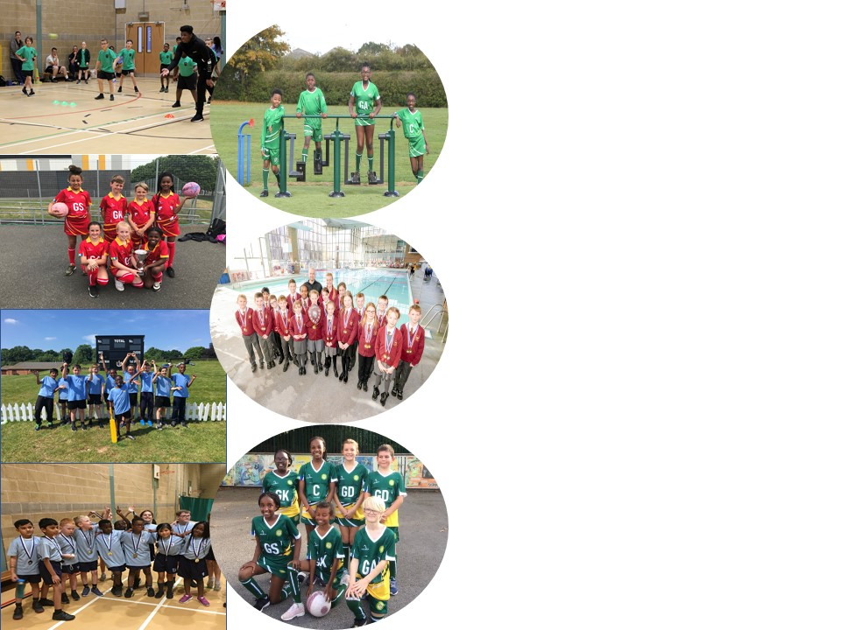
St Gregory’s Catholic Primary School
Sports Funding Impact and Analysis Statement
Following pages are tables showing impact of Government Sports Funding for 2019 - 2020

St Gregory’s Catholic Primary School
Harry Rose Road, Coventry, CV2 5AT
t: 02476 445900 e: admin.sg@romeromac.com w: stgregorys-coventry.org.uk

Background:

The Government has provided funding until 2020 to provide new, substantial primary school sport funding. This funding is being jointly provided by the Department for Education, Health and Culture, Media and Sport, and will see money going directly to primary school Headteachers to spend on improving the quality of sport and PE for all their children.

The sport funding can only be spent on sport and PE provision in schools. OFSTED will play a significant role in ensuring that schools target this funding in areas which will lead to clear outcomes in raising standards and opportunities in PE and school sport for all children throughout the Primary Phase. All schools receive a lump sum of £16,000 plus an additional £10 per pupil. We are proud of the PE curriculum and sporting opportunities that we have on offer at St Gregory’s Catholic Primary School. We believe that the purpose of Physical Education is to inspire and motivate all children to be active in their lives, enabling them to become physically confident. The importance of living a healthy lifestyle and taking regular exercise needs to be encouraged, alongside the teaching of key fundamental skills. We believe that children should have opportunities to apply the skills they have learnt in competitive situations, either within teams or individually. As a result, key values, including team work, resilience, determination and fair play, can be taught and promoted in an active way. We believe these key values are vital for pupils’ development because lots of these are transferable skills, which can be applied to wider life experiences. Furthermore, we believe that PE plays a fundamental role in educating the whole student. Research supports the importance of movement in educating both mind and body. It also helps the children to make informed choices and understand the value of leading a physically active lifestyle. The benefits of physical education can affect both academic learning and physical activity patterns. The healthy, physically active child is more likely to be academically motivated, alert and successful. In the pre-school and primary years, active play may be positively related to motor abilities and cognitive development. We believe that quality physical education teaching is essential in developing motor skills, physical fitness and understanding of concepts that foster lifelong healthy lifestyles.

At St Gregory’s Catholic Primary School, we ensure that the children receive the highest quality of teaching during their PE sessions. We strive to improve children’s ability and skills in sport as well as having a significant impact on the overall fitness and well-being of the children. We aim for all children to develop positive attitudes towards physical activity ensuring all lessons are accessible by providing a range of different activities to challenge every pupil. We believe in challenging ourselves to always strive to be our best and use our God-given talents to their full potential; we endeavour to instil this personal challenge in our children.

Key achievements to date until July 2020: | Areas for further improvement and baseline evidence of need:
- We are working towards the school games mark Bronze level.  - Dedicated PE board which the children can interact with.  - Romero assessment tool developed and ready to use to enhance teaching and learning.  - Youth sports trust Bronze award achieved.  Swimming achievements – Gala. | - Provide better resources for the football and netball teams  - Daily Wake up and shake up activities for all classes.  Pupil survey around after school activities.

Meeting national curriculum requirements for swimming and water safety | Please complete all of the below:
What percentage of your current Year 6 cohort swim competently, confidently and proficiently over a distance of at least 25 metres?  N.B. Even though your children may swim in another year please report on their attainment on leaving  primary school. | %
What percentage of your current Year 6 cohort use a range of strokes effectively [for example, front crawl, backstroke and breaststroke? | %
What percentage of your current Year 6 cohort perform safe self-rescue in different water-based situations? | %
Schools can choose to use the Primary PE and Sport Premium to provide additional provision for swimming, but this must be for activity over and above the national curriculum requirements. Have you used it in this way? Yes/No | No.

Academic Year: 2019/20 | Total fund allocated: £17,740 | Date Updated:
Key indicator 1: The engagement of all pupils in regular physical activity – Chief Medical Officer guidelines recommend that primary school children undertake at least 30 minutes of physical activity a day in school |  |  |  | Percentage of total allocation:
 |  |  |  | %
Intent | Implementation |  | Impact
Your school focus should be clear what you want the pupils to know and be able to do and about what they need to learn and to consolidate through practice: | Make sure your actions to achieve are linked to your  intentions: | Funding allocated: | Evidence and impact: | Sustainability and suggested next steps:
- To introduce activity zones for pupils across all key stages during breaktime and lunchtimes. These activity zones will encourage more pupils to participate in a range of different sports to increase levels of physical activity across year groups.  - Develop an individual to lead in creating a sporting culture within the school. This individual will help enhance the offer to pupils of non-traditional sports at lunchtime and after school clubs. To support the increase of physical activity across all Key Stages within extracurricular activity. This individual will also support and create more schools’ teams to help create opportunities for pupils to represent the school. | - Game on Coaching deliver a range of sports across all year groups to enhance the offer to our pupils during break times and lunch times. A weekly timetable has been developed so all year groups regularly access this opportunity. Weekly registers are kept monitoring participation from pupils within each class. Lunchtime supervisors also assist with these activities to help develop their play leader experience.  - A PE & School Sports Apprentice employed through SCCU to help develop the schools offer of:  - Before & Afterschool Clubs.  - Develop a sporting & physical culture within the school.  Help support & develop school teams for pupils to represent. | - £5,000  - £3,500 | - A lunchtime timetable was arranged at the beginning of the year to enhance lunch time provision of sports. This ensured that all year groups had equal opportunities to work with the game on coaches. Our sports apprentice has continued to support these sessions and will be taking over these sessions in the following academic year. During these session Game On Coaches were delivering to 30 children a day over 5 lunchtimes per week.  - Jamie has been an asset to the school this year and has supported staff in all PE sessions across the school and delivered high quality extra-curricular activities to 100 pupils on an average week.  - He has had an active role in selecting and developing the skills of teams entered the school games mark and catholic sport competitions this year and has attended all sporting events throughout the year with a member of teaching staff.  - Without Jamie’s input into sport this year, many competitive opportunities would not have been able to go ahead, and the children would not have felt prepared. | - Next year the School will be moving away from outside agency to Sport Apprentice and playmakers leading on lunchtime activity to deliver a more comprehensive schedule of activities.  - Jamie is staying at St Gregory’s to continue his apprenticeship until November.  - Jamie will be supporting our play makers award scheme next year along with our PE and Wellness coordinator.  - Jamie will also be developing extracurricular activities next year to hit target groups of children not currently participating in sport. (information gathered via pupil voice)
Key indicator 2: The profile of PESSPA being raised across the school as a tool for whole school improvement |  |  |  | Percentage of total allocation:
 |  |  |  | %
Intent | Implementation |  | Impact
Your school focus should be clear what you want the pupils to know and be able to do and about what they need to learn and to consolidate through practice: | Make sure your actions to achieve are linked to your intentions: | Funding allocated: | Evidence of impact: what do pupils now know and what can they now do? What has changed?: | Sustainability and suggested next steps:
- Increase the presence of teachers delivering PE Lesson and support raising the awareness of sport within the school when delivering PE Lessons or taking children to sporting events.  - To create a leadership pathway for Year 5/6 pupils within the school in a sporting context. The pathway is to create role models within our school for younger pupils to inspire to be. This would give pupils the chance to contribute to the Lunchtime activities within school in a positive way whist being supported by lunchtime supervisors. | - Purchase of Hoodies and T Shirts for St Gregory’s Teaching staff through Andy Blairs Sports  - Purchase of the Playmakers Awards, through UK Sport Leaders. | - £720  - £99 | - Staff Kits have been ordered ready for next year’s cohort which includes the new school badges.  - Unfortunately, the Play makers awards were due to take place during Summer term. Due to COVID-19 epidemic, we were unable to arrange new sporting kit for staff or deliver the play makers programme this year but have pencilled in a date for early September for new year 5’s to take up the training. | - All staff to model PE kits and ensure that they are wearing them for each session. Review the children’s school kit for next year. With new badges.  - Planned to reschedule for September.

Key indicator 3: Increased confidence, knowledge and skills of all staff in teaching PE and sport |  |  |  | Percentage of total allocation:
 |  |  |  | %
Intent | Implementation |  | Impact
Your school focus should be clear what you want the pupils to know and be able to do and about what they need to learn and to  consolidate through practice: | Make sure your actions to achieve are linked to your intentions: | Funding allocated: | Evidence of impact: what do pupils now know and what can they now do? What has changed?: | Sustainability and suggested  next steps:
- To improve progress and attainment of all pupils, the Romero Catholic Academy have appointed a PE & Wellbeing Co-ordinator to review sporting facilities, create coaching skills matrix, marketing, communication and upskilling of staff. | - Appointment of PE & Wellbeing Co-ordinator across the MAC  - To deliver CPD for staff  - Increase in teacher confidence in delivering PE Lessons  - Strategical planning and delivery of MAC Sport Events and Festivals  - Support PE Leads with their role.  - Monitor quality of delivery of PE Lesson across the MAC. | - £4,500 | - PE & Wellbeing Coordinator has help delivered training & support to teachers delivering PE within specific year groups throughout the year. Focusing on the specific planned curriculum areas for PE.  - The PE and wellbeing coordinator has helped to support our PE Lead with developing a structure to put into place to help increase the levels of physical activity in the school, given opportunities for PE lead CPD and liaising opportunities with other Romero schools through PE lead meetings, and supported in transport or attendance in afterschool CCPSA matches. He has worked with Nursey, Year 4, Year 5 PE CPD with teachers,  - The PE coordinator has all given logistical support with external partners to provide training for teachers in and to enrich our PE Curriculum and Extra-Curricular.  - We attend the Romero Transition Event which were host at Cardinal Wiseman and delivered by the PE & Wellbeing Co-ordinator  - Indoor Cricket Year 5  10 Children attended.  - Indoor Athletics Year 5&6  15 children attended.  - Cross Country – Cancelled due to weather | - To continue work with the PE & Wellbeing coordinator to develop our curriculum to encourage CPD for teachers taking ownership for School Games events.  - To trial and develop cross curriculum activities to help increase physical activity levels within the school.  - To enhance provision of alternative sports activities either during lunchtimes or afterschool.
Key indicator 4: Broader experience of a range of sports and activities offered to all pupils |  |  |  | Percentage of total allocation:
 |  |  |  | %
Intent | Implementation |  | Impact
Your school focus should be clear what you want the pupils to know and be able to do and about what they need to learn and to  consolidate through practice: | Make sure your actions to achieve are linked to your intentions: | Funding allocated: | Evidence of impact: what do pupils now know and what can they now do? What has changed?: | Sustainability and suggested  next steps:
- To broaden our PE curriculum across all year groups we will be looking to focus on Dance. We are looking to give all pupils access to high quality teaching within this subject. As part of the delivery there will be an element of CPD to help build confidence of all staff members delivering this area of the PE curriculum.  - To broaden our PE curriculum across all year groups we have worked with many different local companies to enhance the provision and provide the children with extra times throughout the week to be active. As part of the delivery the coaches worked closely with the teachers as an element of CPD.  - To facilitate a wider range of alternative physical activities utilising the equipment to engage children in whole body strengthening exercises during the school day.  - To develop our PE curriculum to maintain high levels of contact time with equipment to create opportunities. | - Suzanne Cantwell Birkin to deliver dance curriculum lesson with all key stages, across Spring Term 19.  - Coaches to work across different year groups.  - One body one life – wellbeing in to work with Reception spring 1  - Chance to shine to work with y1/4 spring 2  - Coventry rugby reading and rugby with y2 Summer 1  - Leamington football coach in to work with y3 Summer 2  - Teachers to develop individual challenges for pupils and give more structure to use of this area.  - Equipment to be purchased to be used in P.E lessons, at lunchtimes and extra curriculum activities. | £0  - £0  - £1000 | - Suzanne worked across all year groups in line with the theme learning focus’s and enhanced cross curricular learning.  We were due to have a year group perform again this year, however due to unprecedented events this was not able to go ahead.  - The outside agencies offered a range of opportunities for all our classes. Through pupil voice all children expressed how much they enjoyed these sessions.  These also enhanced the provision of sport and enhanced our school abilities for competitive sports.  - Across the school Teachers are becoming more active in their PE sessions and are increasingly aware of the equipment and how this can be utilised in PE sessions as well as integrated throughout the day. Most classes also took part in the Joe Wicks school challenge this year.  - Unfortunately, due to time limitation due to COVID-19 epidemic, we were unable to audit and order new equipment for this year. | - Suzanne will continue to enhance our children’s learning and deliver CPD to teachers for the next academic year.  - We will be scheduling the same companies to come in and offer similar sporting opportunities for our classes again next year.  - We will be also looking to enhance this by liaising with other local companies.  - Select some of these sports as part of our school games mark competitions and use these sessions to guide team selections.  - PE Lead to offer further CPD sessions during staff meetings to enhance teacher’s knowledge further and provide a range of teaching resources and ideas to support physical activities in the classroom and during PE sessions.  - To successfully audit and order new netball posts and football nets in September for the 20-21 academic year.
Key indicator 5: Increased participation in competitive sport |  |  |  | Percentage of total allocation:
 |  |  |  | %
Intent | Implementation |  | Impact
Your school focus should be clear what you want the pupils to know and be able to do and about what they need to learn and to  consolidate through practice: | Make sure your actions to achieve are linked to your intentions: | Funding allocated: | Evidence of impact: what do pupils now know and what can they now do? What has changed?: | Sustainability and suggested  next steps:
- Facilitate access of sporting opportunities across the city.  - To engage a range of children in wide range of competitive sports and competitions.  - To achieve the bronze school games mark award. | - Lease minibus to provide the required transport to attend sporting events, swimming programmes and active learning opportunities.  - Membership and participation in Catholic Primary Sports Association & Competitions (CCSPPA) and Romero transition activities.  - Membership and participation in school games competitions to achieve the school games mark Bronze award. | - £2,500  - £100  - £200 | - With the provision of the minibus it has given us a lot more flexibility and capacity to attend all the above events and lots of other sporting opportunities and friendly matches with a range of schools. We have increased our attendance to sporting events and fixtures 50% with involvement within the School Games and more children representing the school over KS2.  - We participated and attended as many CCSPPA competitions as possible. We also had netball and football teams who participated in fixtures throughout the year.  - Throughout the year, our children participated in a range of school games competitions.  - Autumn term:  - Girls football 5/6 : 8 girls  - End ball 3/4: 8 ch  - Sports hall athletics 5/6: 15 ch  - Spring term:  - KS1 agility games 1: 30 ch  - Tag Rugby: postponed  - Summer Term:  - Dodgeball: postponed | - We will continue this high level of participation next year.  - Season has been voided due to the COVID19 Outbreak.  - We will continue to pay the contribution fee for the school games mark events and hope to participate in more next year.

Signed off by
Head Teacher:
Date:
Subject Leader: | - Waters
Date: | 05.05.2020
Governor:
Date:

