Dear parents, children, staff and parishioners,

Happy New Year 2024 Everybody!

Dear parents, children, staff, and parishioners,

We hope that everybody had a lovely festive break; the staff would like to express their appreciation for all their Christmas gifts. I hope you have spent quality time together as a family – has anyone seen Easter Eggs appearing in shops already??

At the start of a new year, we look forward in huge anticipation to what it may hold for all of us at St Gregory’s, especially for our pupils. We hope to build on the successes of 2023 and look forward to seeing our children meeting new challenges and achieving their goals, taking the next steps in their journey of faith and most of all being happy and enjoying each day at school in 2024!

We have had a great first week back – the children have been a delight and it was wonderful catching up on their news!

⭐ Star of the Week ⭐
Our Celebration Assembly was full of joy this week as we were told of all of the children’s fabulous achievements. Congratulations to all of our Stars of the Week!
Nursery | Reception | Year 1 | Year 2 | Year 3 | Year 4 | Year 5 | Year 6
N/A | Harrison | Annabelle | John | Lochlan | Jason | Daisy | Keelan-Jack
P.E. Days (come to school dressed in P.E Kits)
n/a | Tuesday & Thursday | Wednesday  & Friday | Thursday  & Friday | Tuesday  & Wednesday | Wednesday  & Thursday | Wednesday  & Thursday | Wednesday & Thursday
House Point Winner |  | Weekly Winner: Belgrade ~ 311! |  |  | Overall Winner: Belgrade ~ 2012

📣 Reception September 2024📣
Reminder that applications close on January 15th for places to start Reception on 1st September 2024.
Please note, even if your child attends St Gregory's nursery and you wish for them to attend our Reception, you must still fill in an application as a place is not automatically guaranteed. To apply click here!
Please also contact the school office if you would like to take a tour- we wholeheartedly recommend you visit so you can see all the school in action and fully experience the Catholic ethos on offer.

Nursery Applications for September 2024 – Now Open!
We are now also taking applications for our Nursery for a September 2024 start. Please contact the office if you would like an application pack

Holiday request forms
Please can I remind you that if you decide to go on holiday during school time, then you must complete a Holiday Request Form. As stated in our Attendance Policy – no holidays in Term Time will be authorised by the Principal. If a child is absent for more than 4 days then on the fifth day a penalty notice will be issued. This also applies to children that are absent from school for a number of days or where attendance has fallen.

Uniform Update
‘The Gregory’s way is being smart for school each day!’
Please can I remind you that we are currently asking the children to come dressed in Winter Uniform. This means that they should be dressed in a blue collared shirt and be wearing a school tie. Many of the children are still in polo shirts which is our Summer Uniform. Black boots do not form part of our uniform policy either, girls should be in black shoes please. We are more than happy for them to wear boots if they are walking to school and change once they get to their cloak room as some of them have been doing. Thank you for your cooperation with this.

A reminder that you are now able to purchase uniform from Cat Ballou rather than the school office. This means that you can now purchase uniform at all points of the year (especially in school holidays!) and can also order and pay for uniform complete with delivery online should you wish to. Our uniform range can be found here: https://www.catballou.co.uk/product-category/schools/st-gregorys-primary-school/
Here you can also purchase ties which now come in an elasticated version too! We have acted on your feedback to make this change!

Extra-Curricular Clubs
We still have some availability for our Extra-Curricular Clubs. Take a look below and head to Arbor to sign your child up should they wish to attend:
Club | Day & Time | Year Group(s) | Staff | Costing | Booking Link
Football Club | Monday 3:20pm – 4:15pm | Years 1, 2, 3 & 4 | Mr Duggins | £12 per half term | Arbor
Speed Stacking / Chess Club | Tuesday 3:20pm – 4:15pm | Years 4, 5 & 6 | Mr Duggins | Free Club | Arbor
Dance Club | Tuesday 3:20pm – 4:20pm | Years Rec, 1, 2, 3 & 4 | External | £16 per half term | Arbor
Bench Ball | Wednesday 3:20pm – 4:15pm | Years 1, 2, 3 & 4 | Mr Lindley | £12 per half term | Arbor
Netball Club | Wednesday 3:20pm – 4:15pm | Years 3, 4, 5 & 6 | Mrs Scullion | Free Club | Invite Only
Girls Football | Thursday 3:20pm – 4:15pm | Years 3, 4, 5 & 6 | Mr Lindley | Free Club | Invite Only
Gymnastics | Thursday 3:20pm – 4:15pm | Years 1, 2, 3 & 4 | Mr Duggins | £10 per half term | Arbor
Boys Football Team | Friday 3:20pm – 4:15pm | Year 5 & 6 | Mr Sweatman & Mr Hastings | Free Club | Invite Only

Staffing Update!
We are saying a big St Gregory’s hello to some new faces! They have settled into St Gregory’s life wonderfully and we are looking forward to working with them

Miss Mount
Nursery Teaching Assistant

Mrs Padigar
Teaching
Assistant

Mrs Redgrave
Teaching
Assistant

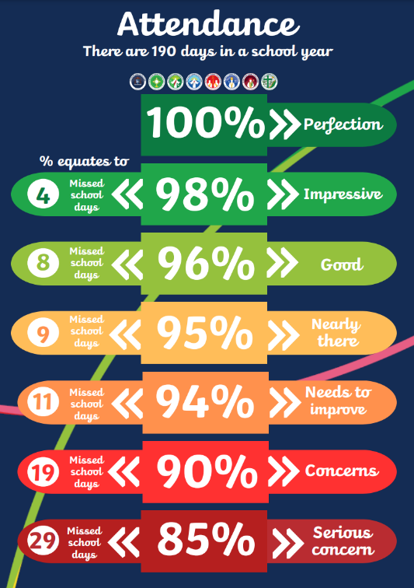
St Gregory’s Attendance
Nursery | 97.56%
Reception | 92.11%
Year 1 | 96.93%
Year 2 | 95.2%
Year 3 | 95.65%
Year 4 | 95.4%
Year 5 | 94.6%
Year 6 | 93.97%

This week’s whole school attendance percentage is

95.06%

We are aiming for at least 97%

Matters Arising
If you have a concern about your child, please book an appointment to discuss with your child’s class teacher by either phoning or emailing the Office to make an appointment. In the first instance – the class teacher is the first port of call. If an issue arises and it is not resolved, the next step is to see the Leader of Learning. If a matter is then not resolved – an appointment can be made with a member of the Leadership team – Assistant Principal (Mrs Priest), Associate Principal (Mrs Scullion) or Executive Principal (Mrs Williams).

Leaders of Learning | Nursery & Reception  Miss Mullen | Year 1, Year 2 & Year 3  Mrs Webb | Year 4, Year 5 & Year 6  Mrs McCormick

This is the procedure, and all staff will direct parents through these steps as they have been found as the most efficient way to resolve concerns. Leaders of Learning have the responsibility to lead their ‘mini-school’ and they work hard to make their phase the very best it can be.

Next week at a glance
Date | Time | Activity
Value and Virtue – Compassionate and Loving
Sunday 14th January | 9.30am & 11.30am | Parish Mass at St John Fisher Catholic Church
Monday 15th January | 9.00am | Mission Assembly
Tuesday 16th January | AM  PM | St Gregory’s & St John Fisher Governing Body School Evaluation Morning  Rock Steady Lessons
Friday 19th January | 9.00am | Celebration Assembly
Sunday 21st January | 11.30am | Y3 Celebration Mass – First Holy Communion Preparation Mass

Wishing you a wonderful weekend!
Mrs Scullion
Associate Principal

